Megalux 2019 Students’ programme 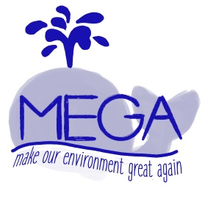
  - Teachers: Sandra Galli history teacher (sandra.galli@education.lu)
  - Patrick Brücher, philosophy teacher
Noëlle Berchem and Françoise Seiwerath, arts teachers

Students’ profile:

Being open-minded, communicative and interested in environment issues!

- Workshop on sustainability
Monday 11th November
In this workshop, students will get the opportunity to put upcycling into practice in an artistic way! Our two committed colleagues from the LMRL arts department are looking forward to not only allowing the participating students a glimpse into what can be made out of stuff you would thing was good for nothing. But they will also help you sustainably produce a Megalux souvenir.

- Environment issues in politics
Tuesday 12th and Wednesday 13th November
The participants are going to debate on current issues concerning the environment in a simulation of the United Nations, called MUN. In order to ensure that all students can feel confident and well prepared they will receive a study guide and solid input once all schools have sent in the participants’ data in the beginning of October. The boys and girls will be personally contacted by our Luxembourgish students and also be coached and get to work in teams at the conference itself. Nevertheless, it will certainly be helpful if the students can receive support from their local teachers, too, for preparing this task. Anyway, we are eager to see you get passionately engaged in topics concerning the future of our planet!

